HW6 Virtual Cluster

**Exercise**

* Try to access a master node of your cluster. (Make a screenshot)

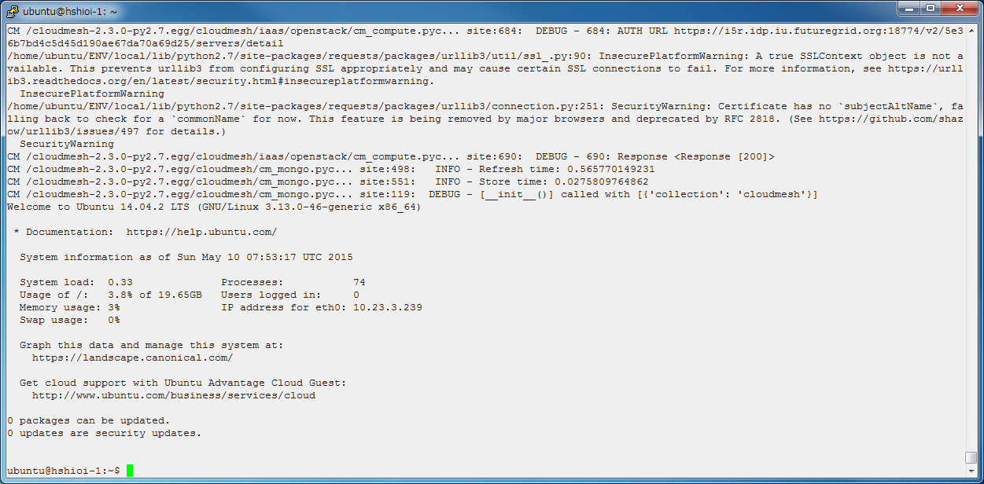

Figure VM1 login

* Create a Virtual Cluster with 2 VMs. (Make a screenshot)

After the command below, I got the screen shots below.

“cm cluster create virtual_cluster_ext --count=2 --ln=ubuntu --cloud=india --flavor=m1.small --image=futuresystems/ubuntu-14.04”

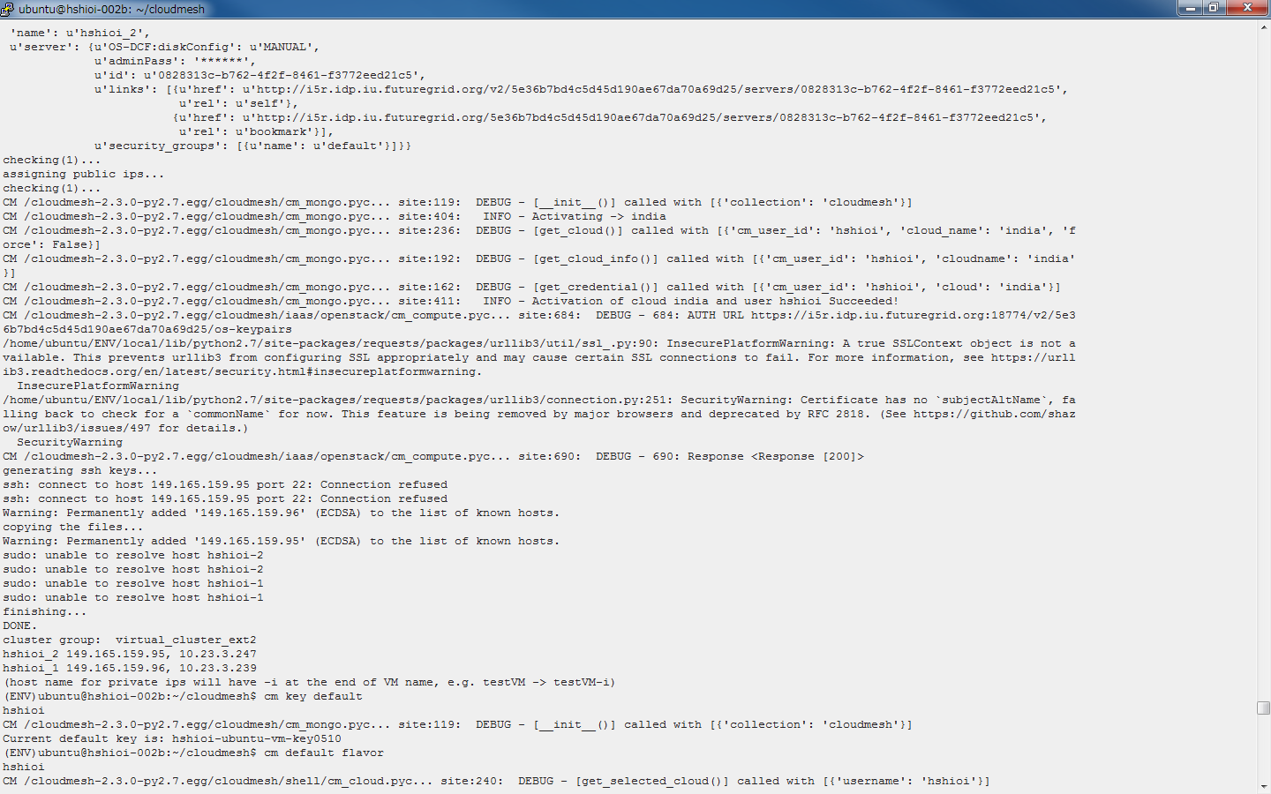

Figure Finish in creating 2 VM instances

The second VM login is as below. (1st VM login was shown in exercise above.)

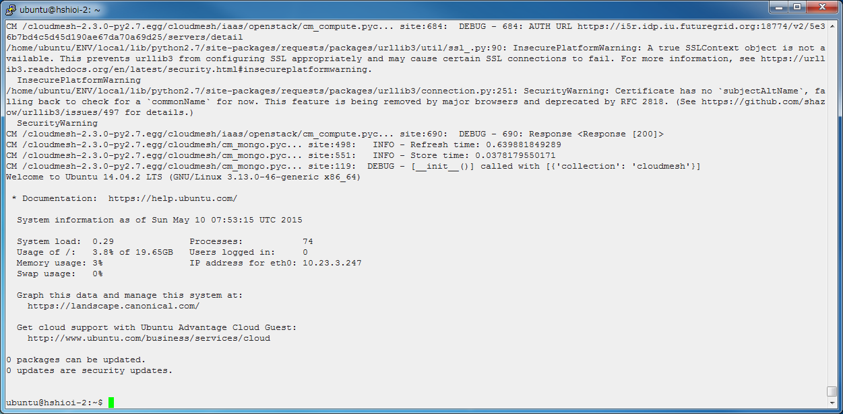

Figure 2nd VM login

Questions:

why does it fail to connect to VM first with “connection refused” messages? (In Fig. 2)

Request for fixation

<http://cloudmesh.github.io/introduction_to_cloud_computing/class/vc_sp15/hadoop_cluster_manual.html#ref-class-lesson-deploying-hadoop-cluster-manual>

The command below is not updated.

It should be “cm default image --name=futuresystems/ubuntu-14.04”

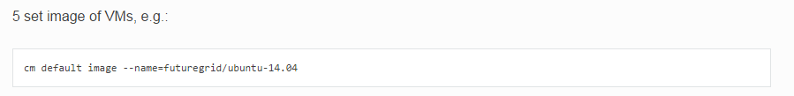

<http://cloudmesh.github.io/introduction_to_cloud_computing/class/vc_sp15/hadoop_cluster_manual.html#ref-class-lesson-deploying-hadoop-cluster-manual>

A way of expressing “manager” and “worker nodes” is confusing. These words look first general words.

“Manager” = “Namenodes”

“Worker nodes” = “Datanodes”

**Lab session for `cluster`` Cloudmesh Command for Virtual Clusters**

**Exercise**

* Create a Virtual Cluster with 2 virtual machine instances
* Use m1.small flavor
* Use ubuntu 14.04 image
* Login to the first VM instance using cm vm login command
* **On your first VM, login to other VM instance (i.e. slave)**
* Make a screenshot or save outputs in a text file
* Submit your screenshots or text files

Only 5th exercise was not shown before. So please look at the below screen shot.

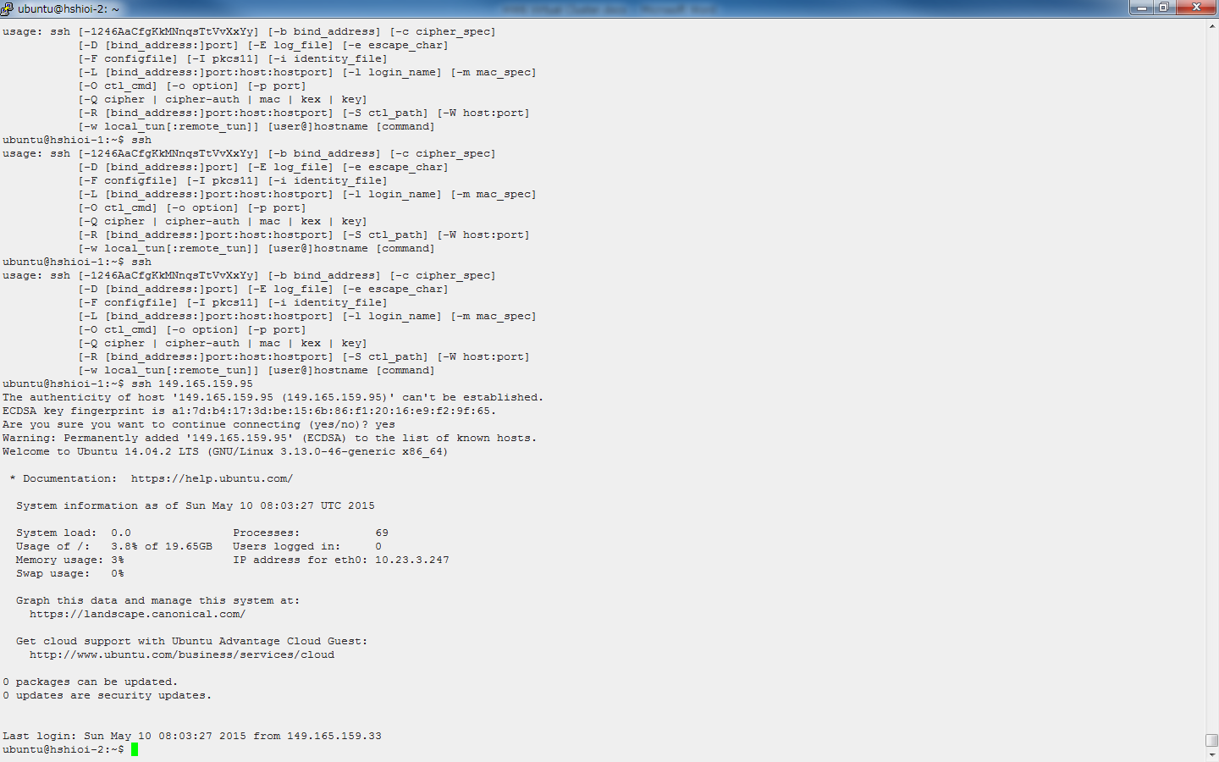

Figure 4 Login to VM 2 from VM 1